TOW THOMAS

DC gain = 0 dB

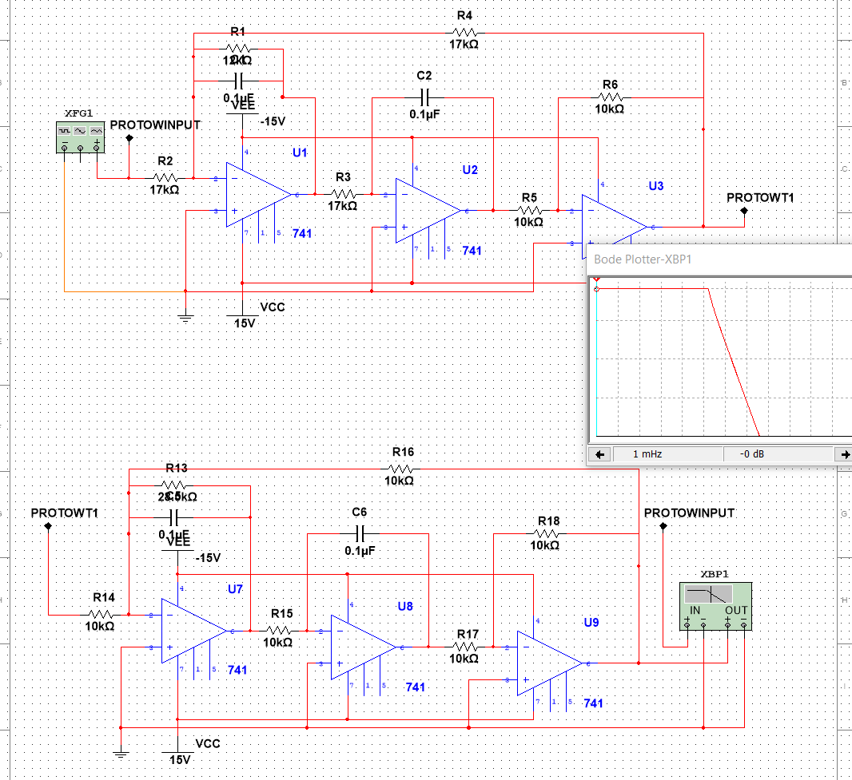

-3 dB at 170 Hz

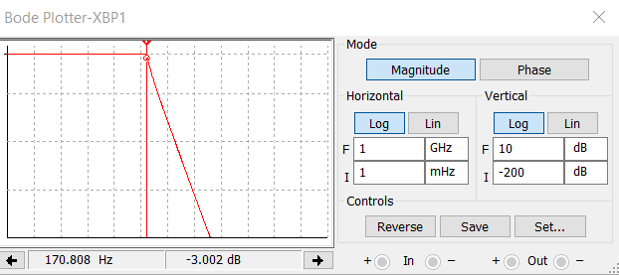

Attenuation at Ws=1800 rad/sec

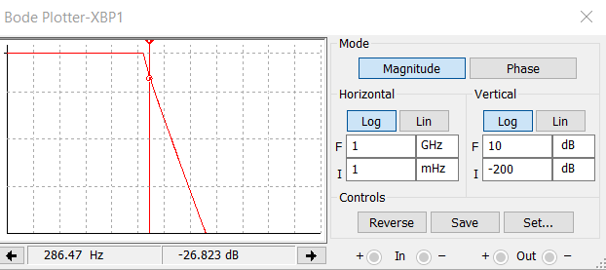

AUCKERBERG-MOSSBERG

DC gain at 0 dB

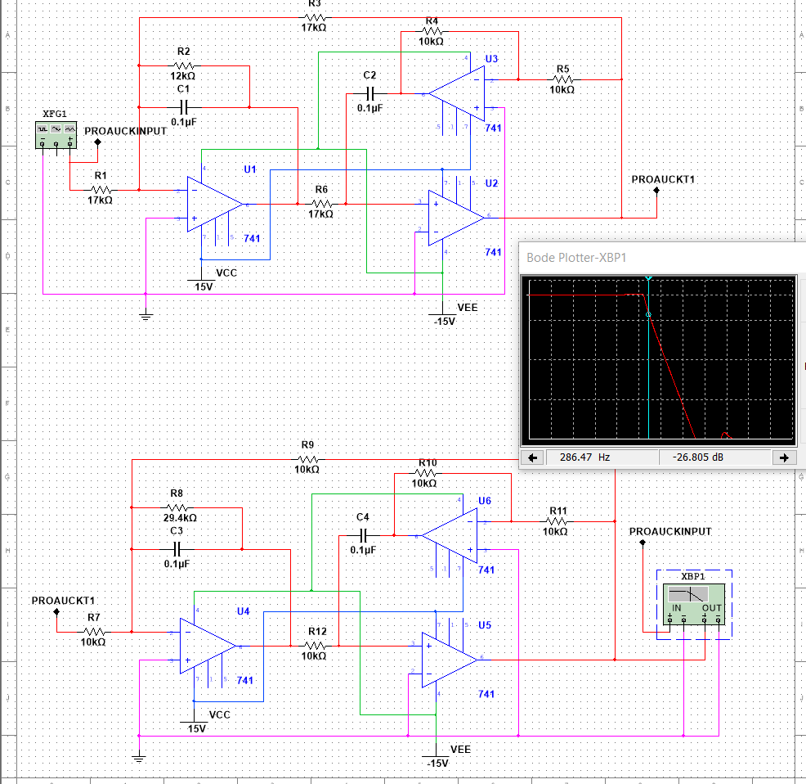

-3 dB at 171 Hz

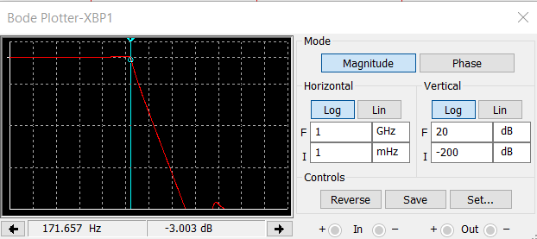

Attentuation at ws(1800 rad/s) =-27dB

